INDIA GENERAL ELECTIONS RESULTS 2024

**Total Seats**

SELECT DISTINCT COUNT(Parliament_Constituency) AS Total_Seats

FROM constituencywise_results;



**Total number of seats available for election in each constituency**

SELECT s.State AS State_Name,

COUNT(DISTINCT cr.Parliament_Constituency) AS Total_Seats

FROM constituencywise_results cr

INNER JOIN statewise_results sr ON cr.Parliament_Constituency = sr.Parliament_Constituency

INNER JOIN states s ON sr.State_ID = s.State_ID

GROUP BY s.State

ORDER BY Total_Seats DESC

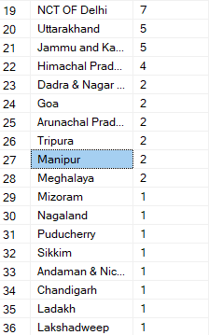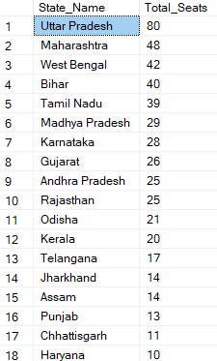

**Total number of seats won by NDA Alliance**

SELECT

SUM(CASE

WHEN party IN (

'Bharatiya Janata Party - BJP',

'Telugu Desam - TDP',

'Janata Dal (United) - JD(U)',

'Shiv Sena - SHS',

'AJSU Party - AJSUP',

'Apna Dal (Soneylal) - ADAL',

'Asom Gana Parishad - AGP',

'Hindustani Awam Morcha (Secular) - HAMS',

'Janasena Party - JnP',

'Janata Dal (Secular) - JD(S)',

'Lok Janshakti Party(Ram Vilas) - LJPRV',

'Nationalist Congress Party - NCP',

'Rashtriya Lok Dal - RLD',

'Sikkim Krantikari Morcha - SKM'

) THEN [Won]

ELSE 0

END) AS NDA_Total_Seats_Won

FROM

partywise_results



**Seats won by NDA alliance parties**

SELECT

party as Party_Name,

won as Seats_Won

FROM

partywise_results

WHERE

party IN (

'Bharatiya Janata Party - BJP',

'Telugu Desam - TDP',

'Janata Dal (United) - JD(U)',

'Shiv Sena - SHS',

'AJSU Party - AJSUP',

'Apna Dal (Soneylal) - ADAL',

'Asom Gana Parishad - AGP',

'Hindustani Awam Morcha (Secular) - HAMS',

'Janasena Party - JnP',

'Janata Dal (Secular) - JD(S)',

'Lok Janshakti Party(Ram Vilas) - LJPRV',

'Nationalist Congress Party - NCP',

'Rashtriya Lok Dal - RLD',

'Sikkim Krantikari Morcha - SKM'

)

ORDER BY Seats_Won DESC

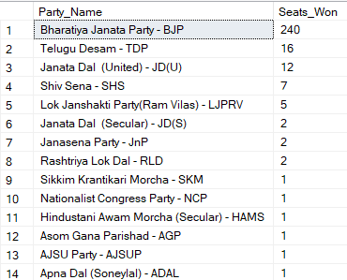

**Seats won by I.N.D.I.A Alliance**

SELECT

SUM(CASE

WHEN Party IN(

'Indian National Congress - INC',

'Aam Aadmi Party - AAAP',

'All India Trinamool Congress - AITC',

'Bharat Adivasi Party - BHRTADVSIP',

'Communist Party of India (Marxist) - CPI(M)',

'Communist Party of India (Marxist-Leninist) (Liberation) - CPI(ML)(L)',

'Communist Party of India - CPI',

'Dravida Munnetra Kazhagam - DMK',

'Indian Union Muslim League - IUML',

'Nat`Jammu & Kashmir National Conference - JKN',

'Jharkhand Mukti Morcha - JMM',

'Jammu & Kashmir National Conference - JKN',

'Kerala Congress - KEC',

'Marumalarchi Dravida Munnetra Kazhagam - MDMK',

'Nationalist Congress Party Sharadchandra Pawar - NCPSP',

'Rashtriya Janata Dal - RJD',

'Rashtriya Loktantrik Party - RLTP',

'Revolutionary Socialist Party - RSP',

'Samajwadi Party - SP',

'Shiv Sena (Uddhav Balasaheb Thackrey) - SHSUBT',

'Viduthalai Chiruthaigal Katchi - VCK'

) THEN [Won]

ELSE 0

END) AS INDIA_Total_Seats_Won

FROM

partywise_results



**Seats won by I.N.D.I.A alliance parties**

SELECT Party as party_name, Won as seats_won

FROM partywise_results

WHERE Party IN(

'Indian National Congress - INC',

'Aam Aadmi Party - AAAP',

'All India Trinamool Congress - AITC',

'Bharat Adivasi Party - BHRTADVSIP',

'Communist Party of India (Marxist) - CPI(M)',

'Communist Party of India (Marxist-Leninist) (Liberation) - CPI(ML)(L)',

'Communist Party of India - CPI',

'Dravida Munnetra Kazhagam - DMK',

'Indian Union Muslim League - IUML',

'Nat`Jammu & Kashmir National Conference - JKN',

'Jharkhand Mukti Morcha - JMM',

'Jammu & Kashmir National Conference - JKN',

'Kerala Congress - KEC',

'Marumalarchi Dravida Munnetra Kazhagam - MDMK',

'Nationalist Congress Party Sharadchandra Pawar - NCPSP',

'Rashtriya Janata Dal - RJD',

'Rashtriya Loktantrik Party - RLTP',

'Revolutionary Socialist Party - RSP',

'Samajwadi Party - SP',

'Shiv Sena (Uddhav Balasaheb Thackrey) - SHSUBT',

'Viduthalai Chiruthaigal Katchi - VCK'

)

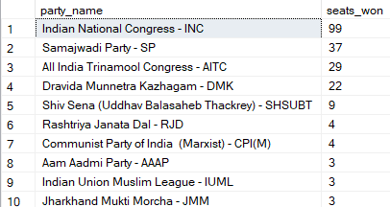ORDER BY seats_won DESC

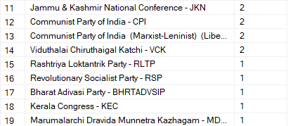

**Add a new column in table partywise_results to get the party alliance as NDA, I.N.D.I.A and OTHER.**

ALTER TABLE partywise_results

ADD Party_Alliance VARCHAR(50);

UPDATE partywise_results

SET party_alliance ='I.N.D.I.A'

WHERE Party IN (

'Indian National Congress - INC',

'Aam Aadmi Party - AAAP',

'All India Trinamool Congress - AITC',

'Bharat Adivasi Party - BHRTADVSIP',

'Communist Party of India (Marxist) - CPI(M)',

'Communist Party of India (Marxist-Leninist) (Liberation) - CPI(ML)(L)',

'Communist Party of India - CPI',

'Dravida Munnetra Kazhagam - DMK',

'Indian Union Muslim League - IUML',

'Jammu & Kashmir National Conference - JKN',

'Jharkhand Mukti Morcha - JMM',

'Kerala Congress - KEC',

'Marumalarchi Dravida Munnetra Kazhagam - MDMK',

'Nationalist Congress Party Sharadchandra Pawar - NCPSP',

'Rashtriya Janata Dal - RJD',

'Rashtriya Loktantrik Party - RLTP',

'Revolutionary Socialist Party - RSP',

'Samajwadi Party - SP',

'Shiv Sena (Uddhav Balasaheb Thackrey) - SHSUBT',

'Viduthalai Chiruthaigal Katchi - VCK'

);

UPDATE partywise_results

SET party_alliance = 'NDA'

WHERE Party IN(

'Bharatiya Janata Party - BJP',

'Telugu Desam - TDP',

'Janata Dal (United) - JD(U)',

'Shiv Sena - SHS',

'AJSU Party - AJSUP',

'Apna Dal (Soneylal) - ADAL',

'Asom Gana Parishad - AGP',

'Hindustani Awam Morcha (Secular) - HAMS',

'Janasena Party - JnP',

'Janata Dal (Secular) - JD(S)',

'Lok Janshakti Party(Ram Vilas) - LJPRV',

'Nationalist Congress Party - NCP',

'Rashtriya Lok Dal - RLD',

'Sikkim Krantikari Morcha - SKM'

);

UPDATE partywise_results

SET party_alliance = 'OTHER'

WHERE party_alliance IS NULL;

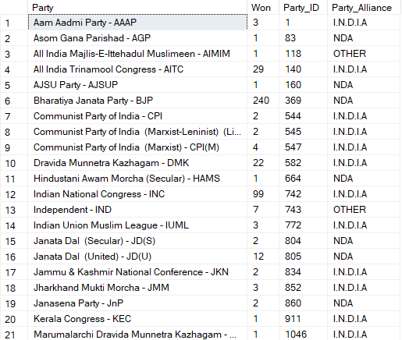

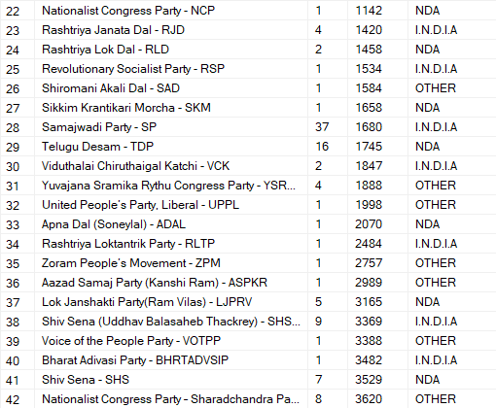

**Winning candidate's name, their party name, total votes, and the margin of victory for a specific state and constituency**

SELECT cr.Winning_Candidate, pr.Party, pr.party_alliance, cr.Total_Votes, cr.Margin, cr.Constituency_Name, s.State

FROM constituencywise_results cr

INNER JOIN partywise_results pr ON cr.Party_ID = pr.Party_ID

INNER JOIN statewise_results sr ON cr.Parliament_Constituency = sr.Parliament_Constituency

INNER JOIN states s ON sr.State_ID = s.State_ID

WHERE s.State = 'Uttar Pradesh' AND cr.Constituency_Name = 'AMETHI';



**What is the distribution of EVM votes verses postal votes for candidates in a specific constituency**

SELECT cd.Candidate,cr.Constituency_Name,cd.EVM_Votes,cd.Postal_Votes,cd.Total_Votes

FROM constituencywise_details cd

INNER JOIN constituencywise_results cr

ON cd.Constituency_ID =cr.Constituency_ID

WHERE Constituency_Name ='AMETHI'

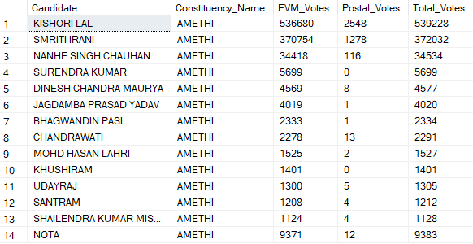

**Which party won most seats in a state, and how many seats did each party win**

SELECT pr.Party,

COUNT(cr.Constituency_ID) AS Seats_Won

FROM partywise_results pr

INNER JOIN constituencywise_results cr ON pr.Party_ID=cr.Party_ID

INNER JOIN statewise_results sr ON cr.Parliament_Constituency=sr.Parliament_Constituency

INNER JOIN states s ON sr.State_ID=s.State_ID

WHERE s.State ='Goa'

GROUP BY pr.Party;

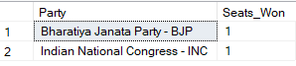

**What is the total number of seats won by each party alliance in each state**

SELECT

s.State,

SUM(CASE WHEN pr.Party_Alliance = 'NDA' THEN 1 ELSE 0 END) AS NDA_Seats_Won,

SUM(CASE WHEN pr.Party_Alliance = 'I.N.D.I.A' THEN 1 ELSE 0 END) AS INDIA_Seats_Won,

SUM(CASE WHEN pr.Party_Alliance = 'OTHER' THEN 1 ELSE 0 END) AS OTHER_Seats_Won

FROM

partywise_results pr

INNER JOIN

constituencywise_results cr ON pr.Party_ID = cr.Party_ID

INNER JOIN

statewise_results sr ON cr.Parliament_Constituency = sr.Parliament_Constituency

INNER JOIN

states s ON sr.State_ID = s.State_ID

GROUP BY

s.State;

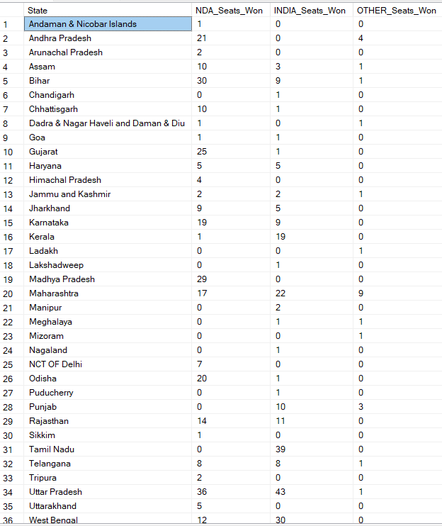

**Which candidate received the highest number of EVM votes in each constituency(Top 10)**

SELECT TOP 10 cr.Constituency_Name,cd.Candidate,SUM(cd.EVM_Votes) AS EVM_Votes_Per_Candidate

FROM constituencywise_details cd

INNER JOIN constituencywise_results cr ON cd.Constituency_ID = cr.Constituency_ID

GROUP BY cr.Constituency_Name,cd.Candidate

ORDER BY EVM_Votes_Per_Candidate DESC

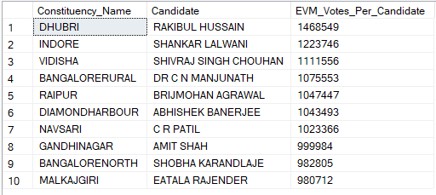

**Which candidate won and which candidate was the runner’s up in each constituency of a specific state in 2024 elections**

WITH Ranked_Candidate AS (SELECT cd.Candidate,

cr.Constituency_Name,

cd.EVM_Votes,

cd.Postal_Votes,

cd.EVM_Votes + cd.Postal_Votes AS Total_Votes,

ROW_NUMBER() OVER (PARTITION BY cd.Constituency_ID ORDER BY cd.EVM_Votes + cd.Postal_Votes DESC) AS Vote_Rank

FROM constituencywise_details cd

INNER JOIN constituencywise_results cr ON cd.Constituency_ID = cr.Constituency_ID

INNER JOIN statewise_results sr ON sr.Parliament_Constituency = cr.Parliament_Constituency

INNER JOIN states s ON s.State_ID = sr.State_ID

WHERE s.State='Maharashtra'

)

SELECT rc.Constituency_Name,

MAX(CASE WHEN rc.Vote_Rank =1 THEN rc.Candidate END) AS Winning_Candidate,

MAX(CASE WHEN rc.Vote_Rank =2 THEN rc.Candidate END) AS First_Runners_Up

FROM Ranked_Candidate rc

GROUP BY rc.Constituency_Name

ORDER BY rc.Constituency_Name

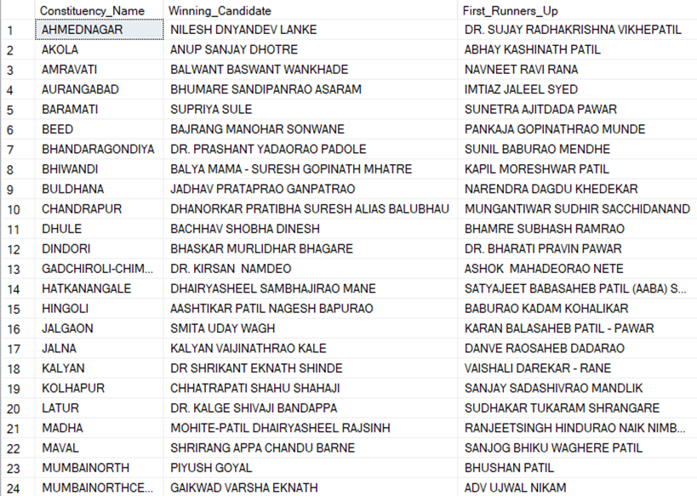

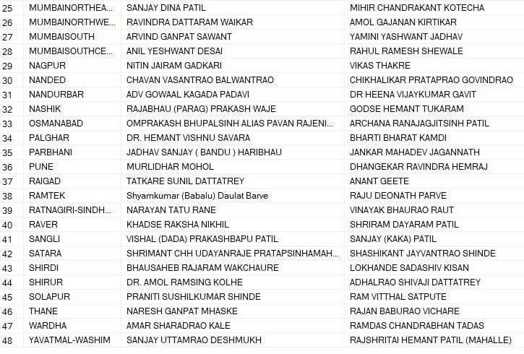

**For the state of Maharashtra, what are the total number of seats, total number of parties, total votes (including EVM and Postal), and the breakdown of EVM and Postal votes**

SELECT

COUNT(DISTINCT cr.Parliament_Constituency) AS Total_Seats,

COUNT(DISTINCT pr.Party) AS Total_Number_Of_Parties,

COUNT(DISTINCT cd.Candidate)AS Candidate_Count,

SUM(cd.EVM_Votes + cd.Postal_Votes) AS Total_Votes,

SUM(cd.EVM_Votes) AS Total_EVM_Votes,

SUM(cd.Postal_Votes) AS Total_Postal_Votes

FROM constituencywise_results cr

INNER JOIN partywise_results pr ON pr.Party_ID=cr.Party_ID

INNER JOIN constituencywise_details cd ON cr.Constituency_ID= cd.Constituency_ID

INNER JOIN statewise_results sr ON sr.Parliament_Constituency=cr.Parliament_Constituency

INNER JOIN states s ON s.State_ID =sr.State_ID

WHERE s.State='Maharashtra';

